In centered cosine similarity (also called adjusted cosine similarity) we subtract the row mean to remove each user's rating bias.
1. Problem: Different users rate differently
Some users always give high ratings, while others give low ratings, even if they like the same items.
Example:
User | HP1 | HP2 | TW | SW1
A | 4 | 3 | 5 | 1
B | 5 | 5 | 4 | –

- User A tends to give moderate ratings.
- User B tends to give high ratings.

If we compare raw ratings, the system might think they are different, even though they like similar movies.

2. Solution: Center the ratings
We subtract the row mean (user average) from each rating:
$$\text{Centered Rating}=r_{ui}-{\overset{ˉ}{r}}_{u}$$
where
- $r_{ui}$= rating by user $u$for item $i$
- ${\overset{ˉ}{r}}_{u}$= average rating of user $u$

3. Example:
Row A has ratings:
HP1 | HP2 | TW | SW1
4 | 3 | 5 | 1

Step 1: Find the row mean (average)
$${\text{Mean}}_{A}=\frac{4+3+5+1}{4}=\frac{13}{4}=3.25$$
Step 2: Subtract the mean from each rating
$$\text{New Rating}=\text{Original Rating}-\text{Row Mean}$$
Movie | Original | Minus Mean (3.25) | Centered Value
HP1 | 4 | 4 − 3.25 | 0.75
HP2 | 3 | 3 − 3.25 | −0.25
TW | 5 | 5 − 3.25 | 1.75
SW1 | 1 | 1 − 3.25 | −2.25

Step 3: What does this mean?
Now we know how much the user likes a movie compared to their average taste.
Movie | Meaning
0.75 | liked slightly more than average
−0.25 | slightly below average
1.75 | really liked
−2.25 | strongly disliked

4. Why this is important
Subtracting the row mean helps to:
1️⃣ Remove user rating bias
2️⃣ Compare relative preferences instead of raw scores
3️⃣ Improve cosine similarity accuracy
Instead of comparing absolute ratings, we compare how much a user likes something above or below their usual rating.
5. Intuition
Think of it like grading exams:
- One professor grades strictly
- Another grades leniently
Subtracting the average normalizes their grading style, so we compare true preference patterns.

✅ In one sentence:
We subtract the row mean so that cosine similarity compares user preference patterns rather than differences in rating scale.

Item -Item Collaborative Filtering
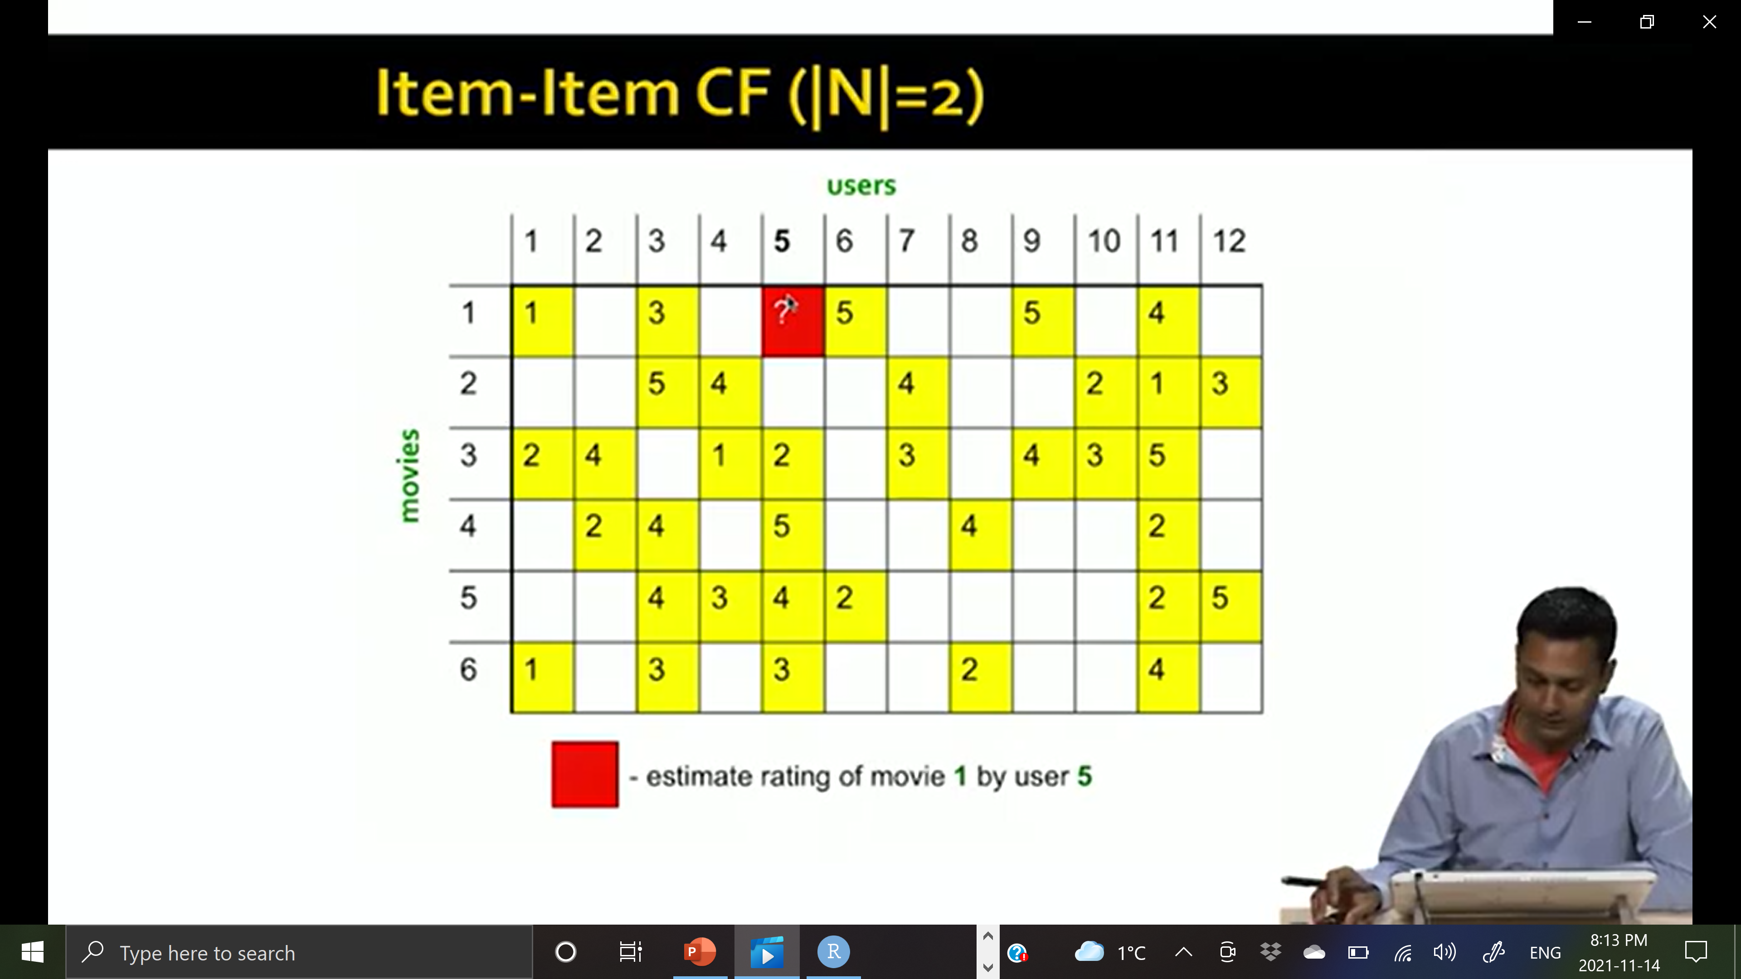

Step 1 — Movie 1 mean
Movie 1 ratings:
User | 1 | 3 | 6 | 9 | 11
Rating | 1 | 3 | 5 | 5 | 4

$${\overset{ˉ}{m}}_{1}=\frac{1+3+5+5+4}{5}=3.6$$
Centered row:
User | 1 | 3 | 6 | 9 | 11
Value | -2.6 | -0.6 | 1.4 | 1.4 | 0.4

Step 2 — Movie 2
Ratings:
User | 3 | 4 | 7 | 10 | 11 | 12
Rating | 5 | 4 | 4 | 2 | 1 | 3
Mean:
$${\overset{ˉ}{m}}_{2}=\frac{5+4+4+2+1+3}{6}=3.17$$
Centered values:
User | 3 | 4 | 7 | 10 | 11 | 12
Value | 1.83 | 0.83 | 0.83 | -1.17 | -2.17 | -0.17

Step 3 — Movie 3
Ratings:
User | 1 | 2 | 4 | 5 | 7 | 9 | 10 | 11
Rating | 2 | 4 | 1 | 2 | 3 | 4 | 3 | 5

$${\overset{ˉ}{m}}_{3}=3$$
Centered values:
User | 1 | 2 | 4 | 5 | 7 | 9 | 10 | 11
Value | -1 | 1 | -2 | -1 | 0 | 1 | 0 | 2

Step — Movie 4
Ratings
User | 2 | 3 | 5 | 8 | 11
Rating | 2 | 4 | 5 | 4 | 2

$${\overset{ˉ}{m}}_{4}=\frac{2+4+5+4+2}{5}=3.4$$
Centered Values
User | 2 | 3 | 5 | 8 | 11
Value | -1.4 | 0.6 | 1.6 | 0.6 | -1.4

Step — Movie 5
Ratings
User | 3 | 4 | 5 | 6 | 11 | 12
Rating | 4 | 3 | 4 | 2 | 2 | 5

$${\overset{ˉ}{m}}_{5}=\frac{4+3+4+2+2+5}{6}=3.33$$
Centered Values
User | 3 | 4 | 5 | 6 | 11 | 12
Value | 0.67 | -0.33 | 0.67 | -1.33 | -1.33 | 1.67

Step — Movie 6
Ratings
User | 1 | 3 | 5 | 8 | 11
Rating | 1 | 3 | 3 | 2 | 4

$${\overset{ˉ}{m}}_{6}=\frac{1+3+3+2+4}{5}=2.6$$
Centered Values
User | 1 | 3 | 5 | 8 | 11
Value | -1.6 | 0.4 | 0.4 | -0.6 | 1.4

After Subtracting Movie Mean (Centered Matrix)
Movies \ Users | U1 | U2 | U3 | U4 | U5 | U6 | U7 | U8 | U9 | U10 | U11 | U12
Movie1 | -2.6 |  | -0.6 |  | ? | 1.4 |  |  | 1.4 |  | 0.4
Movie2 |  |  | 1.83 | 0.83 |  |  | 0.83 |  |  | -1.17 | -2.17 | -0.17
Movie3 | -1 | 1 |  | -2 | -1 |  | 0 |  | 1 | 0 | 2
Movie4 |  | -1.4 | 0.6 |  | 1.6 |  |  | 0.6 |  |  | -1.4
Movie5 |  |  | 0.67 | -0.33 | 0.67 | -1.33 |  |  |  |  | -1.33 | 1.67
Movie6 | -1.6 |  | 0.4 |  | 0.4 |  |  | -0.6 |  |  | 1.4

Calculate the Cosine Similarity with movie 1:

Movies \ Users | U1 | U2 | U3 | U4 | U5 | U6 | U7 | U8 | U9 | U10 | U11 | U12 | Cosine_Sim
Movie1 | -2.6 |  | -0.6 |  | ? | 1.4 |  |  | 1.4 |  | 0.4 |  | 1.00
Movie2 |  |  | 1.83 | 0.83 |  |  | 0.83 |  |  | -1.17 | -2.17 | -0.17 | -0.18
Movie3 | -1 | 1 |  | -2 | -1 |  | 0 |  | 1 | 0 | 2 |  | 0.41
Movie4 |  | -1.4 | 0.6 |  | 1.6 |  |  | 0.6 |  |  | -1.4 |  | -0.10
Movie5 |  |  | 0.67 | -0.33 | 0.67 | -1.33 |  |  |  |  | -1.33 | 1.67 | -0.31
Movie6 | -1.6 |  | 0.4 |  | 0.4 |  |  | -0.6 |  |  | 1.4 |  | 0.59

